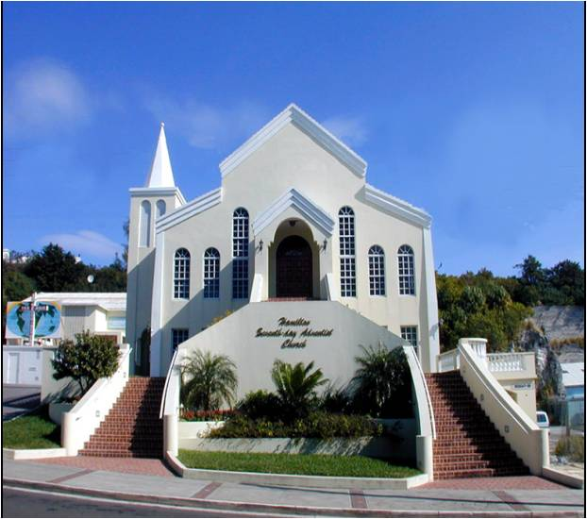

April 20th, 2024
March 30th
1901 - 2024
HAMILTON SEVENTH-DAY ADVENTIST CHURCH

43 King Street, Hamilton HM19 Bermuda

Tel: 292-4276 - Email: hamiltonsda@gmail.com

Pastor: W. DeJaun Tull – telephone #704-0510

Email: dejaun_21@yahoo.com - Instagram: hamiltonsdabda
Facebook: Hamilton King (Hamilton Adventist Bermuda)
Twitter: hamiltonsda www.hamiltonsda.org

The Church Where Worship Is a Joy!
And the Love Is Real

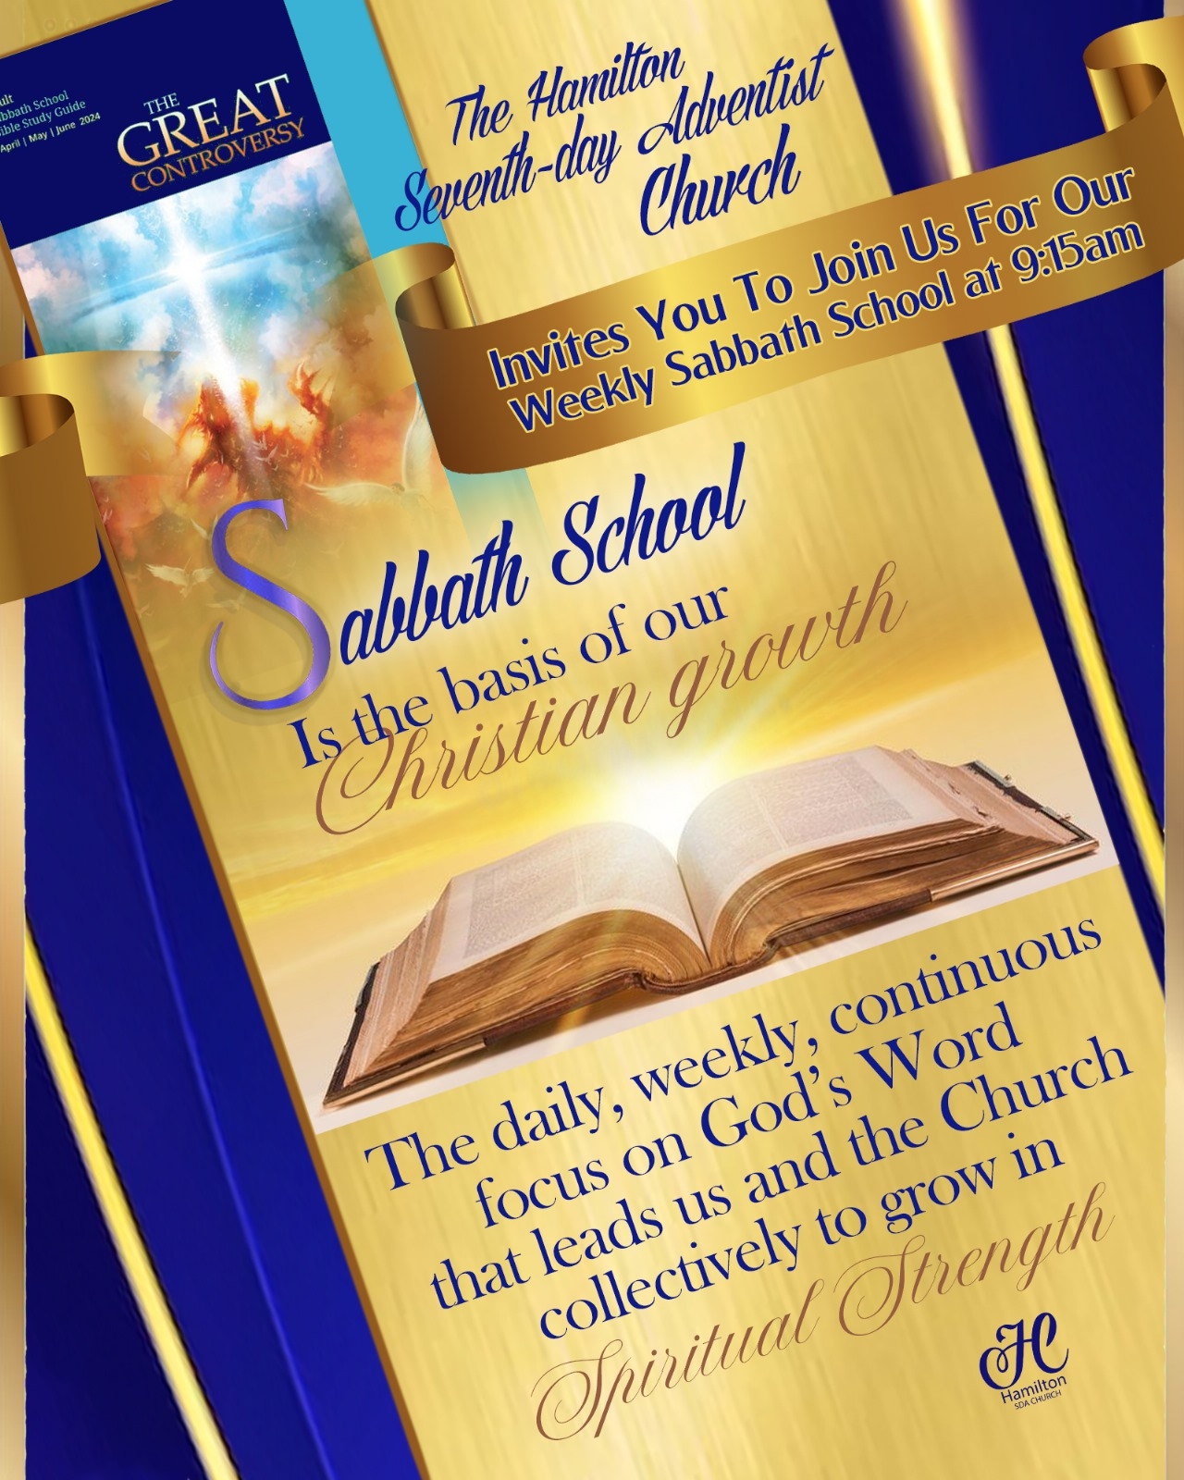

In House - Teachers
Class 1 - Elder Clarence Symonds
Class 2 - Elder Steven Holdipp
Class 3 - Sis. Roslyn Francis
Class 4 - Sis. Eloise Symonds (New Members & Visitors′)
Class 5 - Sis. Carmen Rabain (Young Adults Balcony) 18-40 years old
Class 6 - Couples Ministry - Dennis & Carlita O′Brien in the Youth Center
on the 2nd Sabbath of each month

The Church-At-Study
April 20th, 2024 - 9:00 a.m. - 10:15 a.m.

Mission Statement
"Fostering spiritual growth through regular study of the Word of God
and sharing our faith with others"

Lesson 3 - "Light Shines in the Darkness"

Memory Text: "Then Jesus said to them, ‘A little while longer the light is with you. Walk while you have the light, lest darkness overtake you; he who walks in darkness does not know where he is going" (John 12:35 NKJV).
(Superintendent) – Sis. Deborah Thomas-Gilkes

Song Service - Elder Steven Holdipp

Welcome………………………………………………..…………….Sis. Andrea Harris-Brown
Opening Prayer……………………………………………………………….Sis. Thelma Wong
Mission Spotlight

Family Ties

Lesson Study……………………………………………………………………………...Classes

Closing Remarks & Prayer………………………………………..Sis. Deborah Thomas-Gilkes

Logos
Superintendent Sis. Chanel Bean
Welcome and Introduction of Program & Panelist

Elder Josonne Smith, Moderator

Bro. Craig Outerbridge, Panelist
Opening Prayer

Elder Garth Dixon, Panelist

Bro. Steven Doyling, Panelist

Closing Prayer

THE CHURCH -AT –WORSHIP
PIONEER ADVENTURER AND PATHFINDER CLUB
PATHFINDER DAY: THEME - BELIEVE THE PROMISE

Praise Team 3-Music Minister: Michelle Spenser……....Musicians: Terry Henry - Johnae Furbert
Audio Technician: Shawne Tuzo - Steve Stevens ………………………….Video Director: Jakobi Albuoy
Proclaim Technician: La-Mel Burch……….…….Worship Coordinators: Chanel Bean – Calisis Glasgow
Ushers: Thelma Wong - Leilani Peters…………………………………………Church Clerk: Karen Henry
Nurse on Duty: David Murray

PREPARATION FOR WORSHIP

Call to Worship……………………………….……………………………………......Alexcia Henry

Intercessory Prayer…………………………….……………………………..…Elder Corville Hylton

Prayer Response……………………….………………….……………………….....…...Praise Team

Opening Hymn……………….……#612 "Onward Christian Soldiers"………………...Congregation

LEADERSHIP IN WORSHIP

Welcome…….……..…Gabriela Randolph, Samae Outerbridge, & Aleesia Albright
Remarks & Fellowship…………Directors: Katiuska Guerrero & Apryl Tuzo

CHILDREN IN WORSHIP

Children′s Song……………………………..….…………………………………………Praise Team

Children′s Story…………………………………………………………………………Pedro Durrant

Offertory………………………………….…….........………………………………...…Lara Holdipp
"Local Church Budget"

PRAISE AND WORSHIP

Introduction of Speakers……………………..…………………Taylor Ming & Ca’Mya Rose

Special Music……………………………………………………..….Pioneer Choir
Sermonette …………………..…………….Adventurer Michael Ming

Special Music……………………………………………………..………..…WWJ
Sermonette…………………………………Counselor Neriah Bean

RESPONSE TO WORSHIP

Closing Hymn…………………….… …………………………………………………..Congregation

Benediction…………………………………………………………………………….… Kalani Smith

Benediction Response………………….………………………………………………….Praise Team

Recessional...................................Drill Master Kevin Stewart

Guidelines For…………..

Returning Tithe and Offerings Online is Easy

- Sign into your bank account (HSBC, Butterfield or Clarien Bank)
- Go to “Make a Transfer.”
- Enter the Hamilton Seventh-day Adventist Church’s account:
HSBC Account 010-790384-001 as the receiving bank account.
- In the reference, please indicate the breakdown of your giving
- Confirm the transaction amount and details
- Transfer your funds
Thank you

Guidelines for the allocation (breakdown) of your giving

- If you are returning Tithe ONLY, please mark in the reference: Tithe Only
- If you are returning Tithe and offerings, use the below example:
Tithe of $300 and Offering of $100: T300 CB100
Possible Allocations:
T: Tithe, CB: Church Budget, BF: Benevolent Fund, BI: Bermuda Institute, EL: Local Evangelism, E: Conference Evangelism, S: Local Sabbath School Expenses, SS: Sabbath School Mission

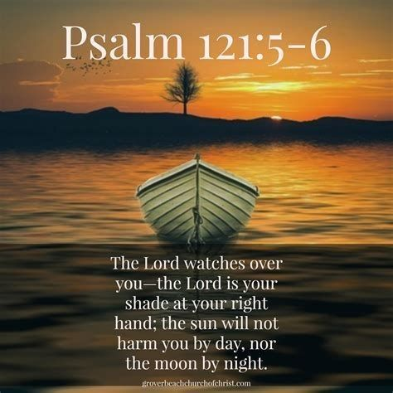

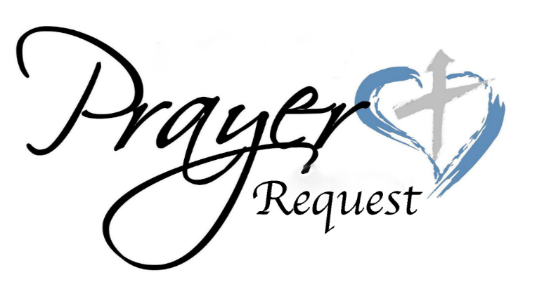

Malcolm Santucci, Zhale Trott, Destiny LeShore Robinson, Deanna Symonds, Colin Smith, Bobby Slaton, La-Mel Burch, Stephanie Wellman, Joy Joell, Dennis & Donna Mapp, Burnell Phillips, Michael Young, Morris & Roslyn Francis, George Burch, Ethlyn James, Maria Adcock, Gerald Barstow, Harriett Nisbett, Dean Rubaine, Jermaine Simons, Andre Gordon, Maisie Tucker, Marjorie Wilson, Norlene Iris, Adele Darrell, Gina, Donnica, & Remy Coddington, Lashay Hollinsid, Gerald Burgess, Claudette & Stephen Manders, Dorothy Thomas, Denise Wilson-Adams, Lois Shiferraw, Cynthia Glen & Janet Ford, Joan Moore, Cynthia Smith, Rose Steede, Shirley Henry, Marie Holdipp, Donna Belton, Willard Fox, William Cann, Helen Burrows, Eugene Eversley, Our Students, Our Seniors, Our Government, and Our Island Home.

Condolences are Extended to: Family & Friends of our beloved member, Belvina Barnes, wife of the late John "Johnny" Barnes.

The Family of the late Michelle Woolf-Felician.
Her….
Husband - Lester Felician
Son - Jayden Coleman
Parents - Robert & Judith Woolf
Sisters - Jennifer Ackah, Donyale Ackah-Eversley, and the late Angela Simons.

Parishioners who need to get in contact with their Elder details are listed below
Elders | Parish | Email | Telephone
Eugene Tatem | Sandy’s | tatem.neugene1@gmail.com | 334-8064
Josonne Smith | Southampton | josonnesmith9068@gmail.com | 505-1430
Mark Matthews | Warwick (A-l) | mattheem@yahoo.com | 799-1768
Michael Spenser | Warwick (J-R) | micspen@hotmail.com | 334-7455
Daffeth Wallace | Warwick (S-Z) | dafwallace@northrock.bm | 332-6292
Steven Holdipp | Paget | stebeth001@gmail.com | 705-1153
Garth Dixon | Pembroke (A-M) | bigdixon2009@gmail.com | 737-8475
Corville Hylton | Pembroke (N-Z) | villetoncore@hotmail.com | 717-2046
Dilveon Bramwell | Devonshire | dilveon.bramwell@gmail.com | 519-5223
Jamal Albuoy | Smith’s | jalbuoy@me.com | 599-4428
La-Mel Burch | Hamilton | lamelburch@gmail.com | 535-4143
Kevin Stewart | St. George’s | kevakvn@gmail.com | 518-8970

CHURCH BIBLE INSTRUCTORS

'Are you or a friend desirous of understanding the Word of God more, and learning God's
expectations of you? Contact any of the Church Bible Instructors listed below:

Eloise Symonds - Cell #517-0459 (WhatsApp) / Email: eloise.l.symonds@gmail.com
Eugene Tatem - Cell #334-8064 (WhatsApp) / Email: tatem.neugene1@gmail.com
Ernestine DeGraff - Email: cae42@yahoo.com
Janet Smith - Email: jdspinky@yahoo.com
Juliet Dillas - Email: julietdillas@gmail.com
Queenicia Williams - Email: queenwilliams91117@gmai

2024

Prayer Meeting Schedule Divine Worship Preaching Schedule

April 24 - Dr. Stanley James April 27 - Dr. Stanley James

May 01 - Elder Dilveon Bramwell May 04 - Dr. Leonard Gibbons (Health Emphasis)
May 08 - Elder Josonne C.D Smith May 11 - Pastor W. DeJaun Tull
May 15 - Elder Jamal Albuoy May 18 - Pastor W. DeJaun Tull
May 22 - Elder Garth Dixon May 25 - Ted Huskins (AUC)
May 29 - Elder Kevin Stewart

June 05 - Pastor W. DeJaun Tull
June 12 - Pastor W. DeJaun Tull
June 19 - Dr. Stanley James
June 26 - Island-wide pre-Campmeeting
Prayer meeting at BI

Hey!
What’s
the Buzzzz

WHO′S ON DUTY
4th, Sabbath
Sabbath School Emphasis Day
April 27th, 2024

ELDERS | Corville Hylton - Josonne Smith - Eugene Tatem
DEACONS TEAM 2 | Leaders: Neville Greene & Dersick Ellen  Deacon Board: Travis Caines - Troy Dean - Loderick Holder -Delwyn Joseph - Malachi Omollo - Charles Trott  (Junior Deacons) Joshua Matthews - Miles Tuzo  (AY Deacons) Travis Caines Jr. - Michael Caines
DEACONESS TEAM B | Wanda Spence (AHD) Chanel Bean - Mylah Burch - Tanaeya Burch - Keisha Dixon - Loderika Showers
WORSHIP COORDINATOR | Sonya Holder
PRAISE TEAM 4 | Michael Spenser
AUDIO TECHNICIAN | Malik Showers - Allan Fox
VIDEO DIRECTOR | Jalon Smith
PROCLAIM TECHNICIAN | Annette Eve
SABBATH SCHOOL | (Superintendent) Roslyn Francis
CHURCH CLERK | Andrea DeSouza
USHERS | Thelma Wong - Leilani Peters
GREETER | Chanel Bean
NURSE ON DUTY | Sansha Randolph

Sunset this Sabbath: 7:48 Sunset next Sabbath: 7:52

Your Week
Announcements -And Up-Coming Events

April  Sabbath 20th  8:00 a.m. | Early Morning Mama in the Sanctuary.
Sunday 21st
Monday 22nd
Tuesday 23rd  11:00 a.m. - 2:30 p.m. | The Happy Seniors Club meet at the center
Wednesday 24th  4:00 p.m. -5:00 p.m.  6:30 p.m. | Community Service Feeding program at the youth center.  Prayer Meeting in the Sanctuary.
Thursday 25th
Friday 26th

Clerks’ Office: Final Reading of Transfer of Membership for Dilveon Bramwell from the Grace SDA Church, Kingston, Jamaica to the Hamilton SDA Church, Hamilton, Bermuda.
To all Hamilton Members - If you are not receiving church emails, nor the weekly bulletin, please complete a contact card, and place it either in the offering plate or return it to Sis. Annette Eve or Sis. Ardeen Williams. The contact cards can be found on the table in each foyer. Annette M. Eve Head Clerk

All Bulletin Announcements/Flyers should be submitted each Wednesday no later than 5:00 p.m. if you wish to have it in the bulletin. Please do NOT send flyers in pdf. Submit all information to - hamiltonsda@gmail.co

Couples Ministry: Prayer Necessary to Right Decision—
The majority of the marriages of our time and the way in which they are conducted make them one of the signs of the last days. Men and women are so persistent, so headstrong, that God is left out of the question. Religion is laid aside, as if it had no part to act in this solemn and important matter. Adventist Home pg. 71.2

We All Have Hope Evangelism
Phase 1
Season of Service (SOS)
April 8 – May 18, 2024
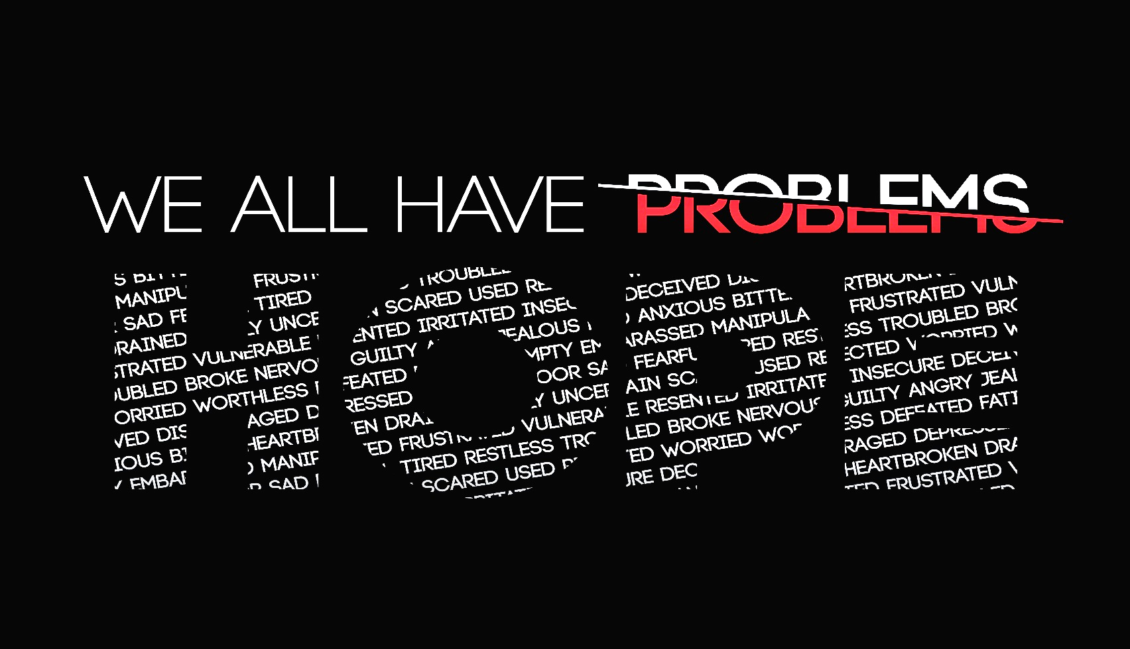

Frequently Asked Questions
Q.1 What is “We all have Hope” Evangelism?

A.1 The “We All have Hope” Evangelism will be held on October 11th – 19th, 2024; with Pastor Roger Hernandez. In preparation for the actually evangelism we are excited to share information on Phase 1 of the 3 Phase preparation for the “We all have Hope Evangelism. Phase 1 is the SOS phase which stands for Season of Service which begins April 8 and ends of 18 May, 2024. This will focus on total membership engagement for the next 40 days.

Q.2 What is a Season of Service?
A.2 Church family, the purpose of the Season of Service is to motivate, and educate members to be the hands and feet of Jesus in our communities through a 40 day Season of Service (SOS). It has two components beginning with us first - that is beginning with us having daily devotionals for 40 days. Each daily lesson contains three parts, and they are:
See it – starts with scripture, internalize it believe it and share it.
Obey it – this part shares a few principles to learn
Share it – turn your knowledge about service into action. It provides three options of service activities for you to do daily. It provides wonderful self-devotional that can also be used in morning family worship that covers a different topic every day.
Q.3 How can I receive a copy of the daily devotional?
A.3 The daily devotionals will be divided into weekly compilations and will distributed via email on the Monday for Tuesday start or hardcopy upon request and will be distributed on Sabbaths for the next six weeks.
Q.4 What is the Small Group Bible Study and how is it used over the next forty days?

A.4 Each week at the end of each devotional booklet will be one small group study that you can use in homes, workplaces, during Sabbath gatherings or wherever God leads you. They are simple, very easy and practical.

Q.5 Are there any other things we can be engaged in and participate in as a church?

A.5 Yes, you can join in the following church and function service activities:

- Community Service (Wednesdays 4:00 p.m. -5:00 p.m.
- 50th Anniversary of Community Services – April 13th – distribution and visitations
- End of Season of Service Celebration with the Youth – May 18
- Departments/Ministries may wish do engage in a project

Additional information will be provided on the projects closer to the date of the project.

Q.6 When can members share the wonderful experiences they will be having during the 40 days of the Season of Service?

A.6 Every Wednesday night during Prayer Meeting you will have the opportunity to share your testimony and experiences during the Season of Service (SOS).

Q.7 What about Phase 2?

A.7 You will hear more about Phase 2 R.A.M.P. that starts June 30 and ends August 9, 2024 all in preparation for the ‘We all Have Hope Evangelism” – you will hear more about this closer to the date.

Q.8 Is it anything else we can do during the Season of Service?
A.8 The key to ensuring we are prepared and we are preparing others is to bath everything we do in prayer and ask for the outpouring of the Holy Spirit.

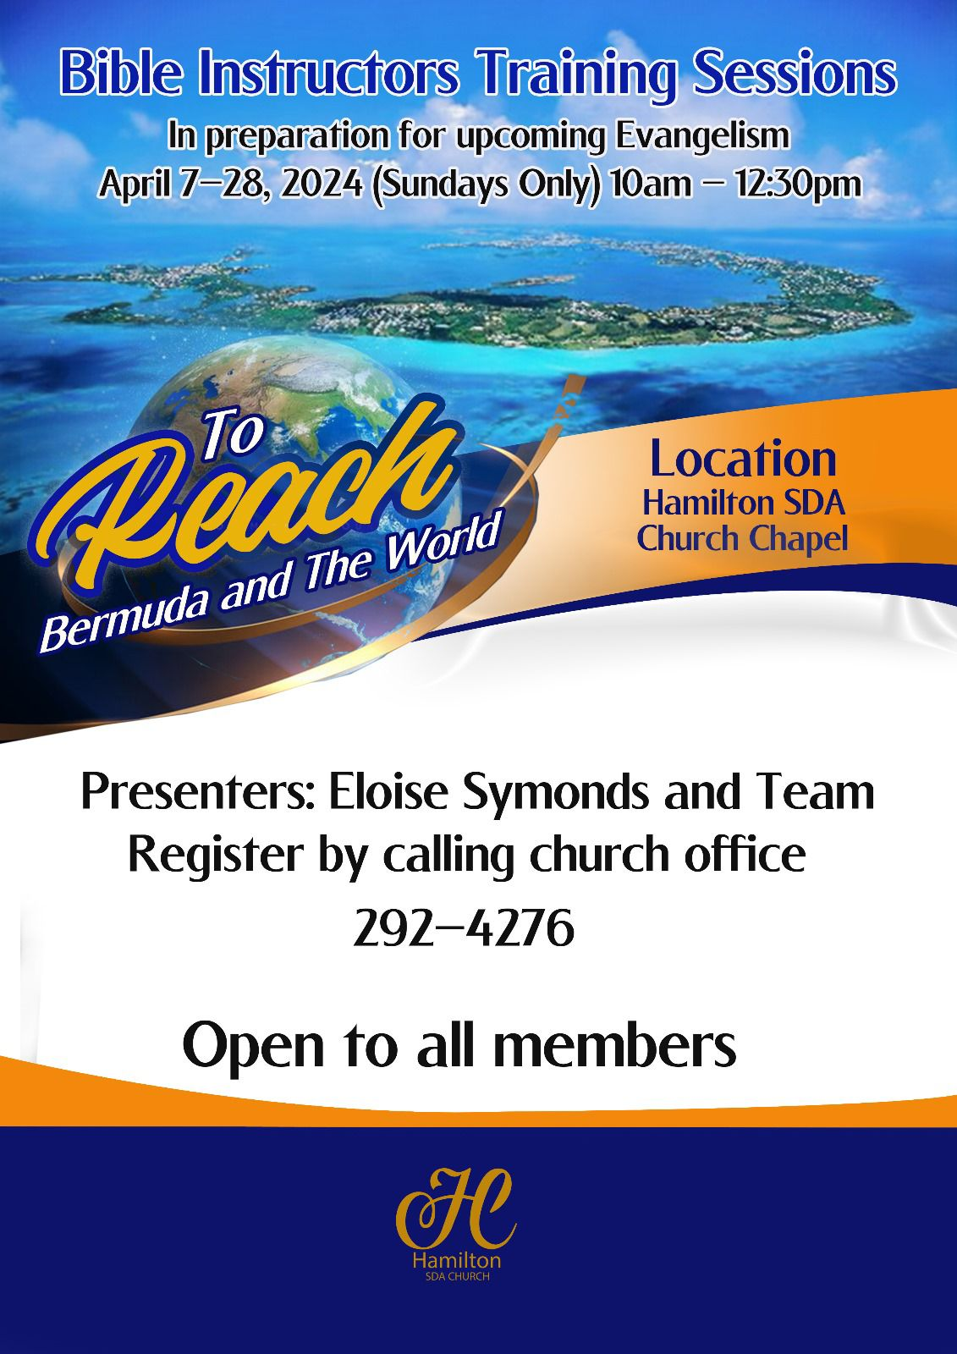

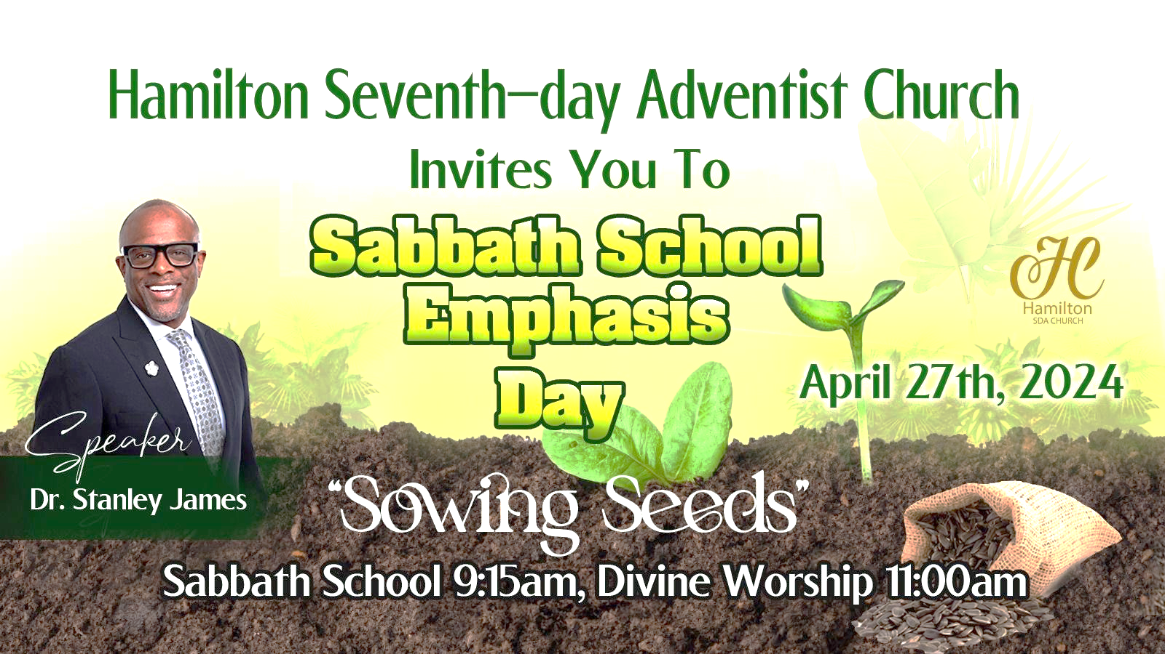

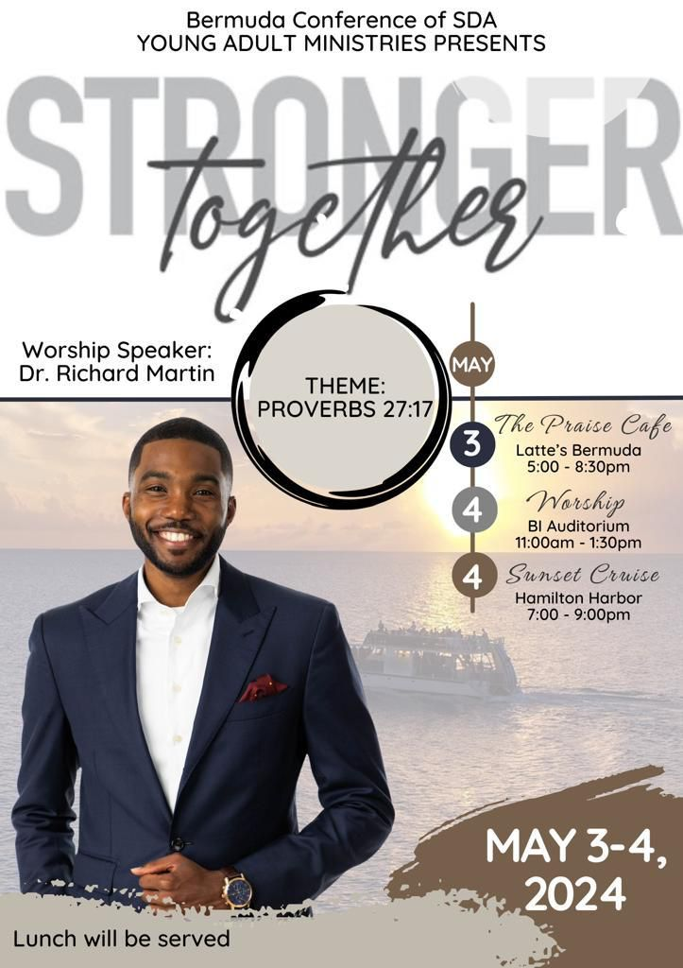

Pathfinder Spotlight

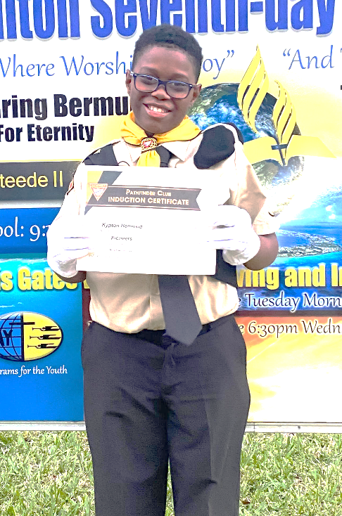

Name: Kypton Hollinsid
Age: 12
Favorite Colors: black and white
Favorite Bible Verse: Psalm 23

Is this your first Camporee? yes
What are you looking forward to the most about Camporee? I am looking forward to meeting new people. Kypton will be attending the Pathfinder Camporee in August.

To donate to Kypton:
- You can place your donation in a tithe envelope and label the envelope “Believe Hollinsid”
- Online: HSBC 010 -790 384 – 001 Use the reference “Believe Hollinsid”

*For more information on the camporee visit: www.camporee.org*

APRIL BIRTHDAYS
 | April 1st -5th
01 Keith Lowe | 02 Albert Caisey | 03 Stedre Ming
03 Gianni Burgess | 03 Donalis Alleyne | 03 Aaron Kelly
03 Carrie Bascome | 03 Sean Kelly | 04 Brianna Russell
04 Garrow Lightbourne
 | April 6th - 12th
06 Glenda Trott | 06 Andrea Wilson | 07 Ashley Blair
09 Sherall Moore | 09 Annette Eve | 09 Pamela Walton
09 Paulette Smith | 11 Selita Crockwell-Daniels | 11 Kimberly Fox
11 Lauren Dill | 11 Marquita Lee | 11 Queenicia Williams
11 Paulette Lightbourne
 | April 13th - 19th
13 Udora Ford | 13 Nickesha Smith | 13 Eugene Richardson
14 Arjah Stirling | 14 Chioke Hayward | 14 Barbara Matthie
14 My-Ah Outerbridge | 15 Terrae Tuzo | 16 Kevin Rogers
17 Myron Ingham | 17 Meko Lightbourne | 18 J. Derek Ming
18 Malcolm Seymour | 18 Shanna-Lee Burch | 18 Simbarashe Chigwande
19 Deborah Gilkes
 | April 20th - 26th
20 Andre Hollinsid | 20 Gaynell Hollis | 21 Jotessa Musson
21 Tannecia Hill | 22 Tammie Bremar | 23 Frank Alban
23 Bria Williams-Watkins | 23 Katherina Gibbons | 24 Kevina Butterfield
24 Tyler Caines | 24 Apryl Tuzo | 25 D$'$ziah Coddington
25 Verlicia Scott
 | April 27th - 30th
28 Andrea Brown | 28 Damien Daniels | 29 Shurnett Caines
29 Tony Fox | 30 Cynthia Liburd | 30 Laura Tucker

April Anniversaries

11 Eugene and Judy Richardson | 15 Onesimus and Celia-Ann Nzabalinda
23 Malik and Loderika Showers

